The XPAG Cooling System
This is a photo essay to give you a starting point when discussing (or trying to figure out) the cooling system on the XPAG engines.
The XPAG improved the cooling of earlier MG engines by adding a water pump to the thermo-siphon principle of cooling. We’ll start at the front of the engine where the water pump bolts. As you can see by the wire threaded through the mounting holes you’ll need to put a sealant on your studs/bolts to ensure that no water leaks occur in this area since they go through to the water cavity.
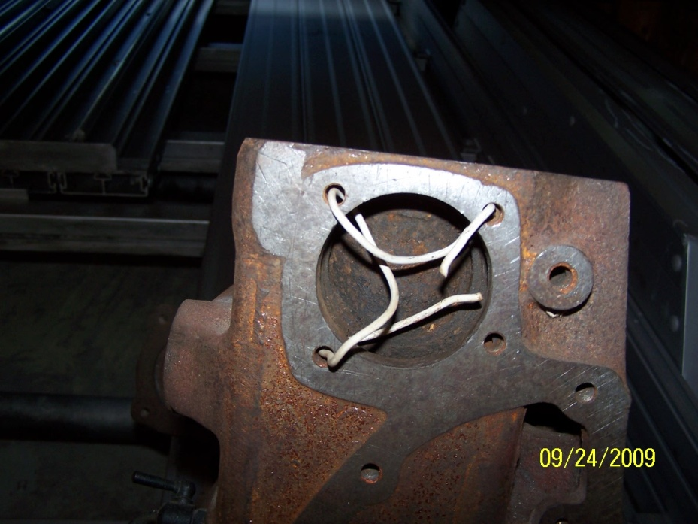
Inside the block around the water pump there are three passages. These first two that I’ve put the wire in are part of the thermo-siphon system. There would be little circulation action felt in this area because these passages are behind the impeller. I imagine these are there to help the block fill with water when the engine is cold and to let some hot water mix with the cooler water when the engine is running.
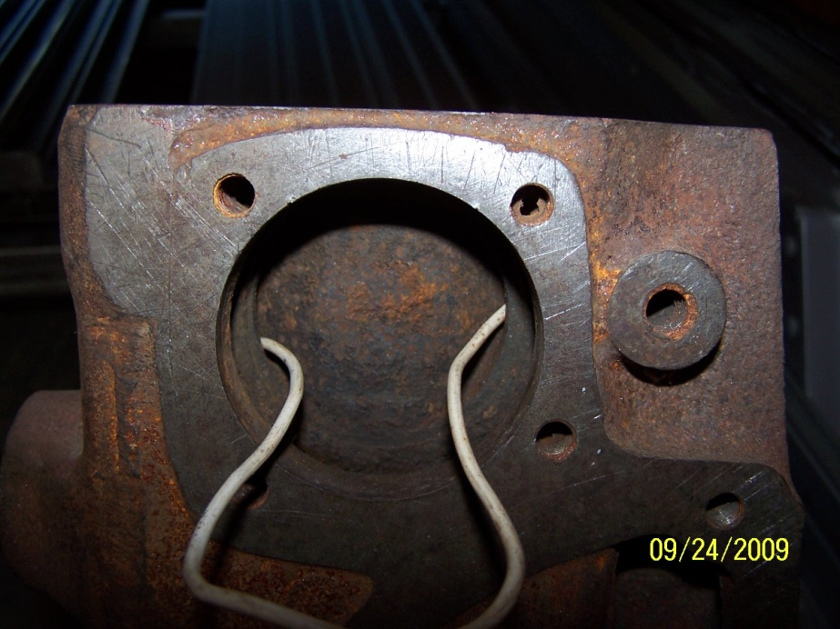
This next photo shows the larger passage at the bottom of the water pump area. This passage connects to the square protrusion on the side of the block that is normally hidden under the intake and exhaust manifolds. This passage carries the water from the water pump to the back of the block.
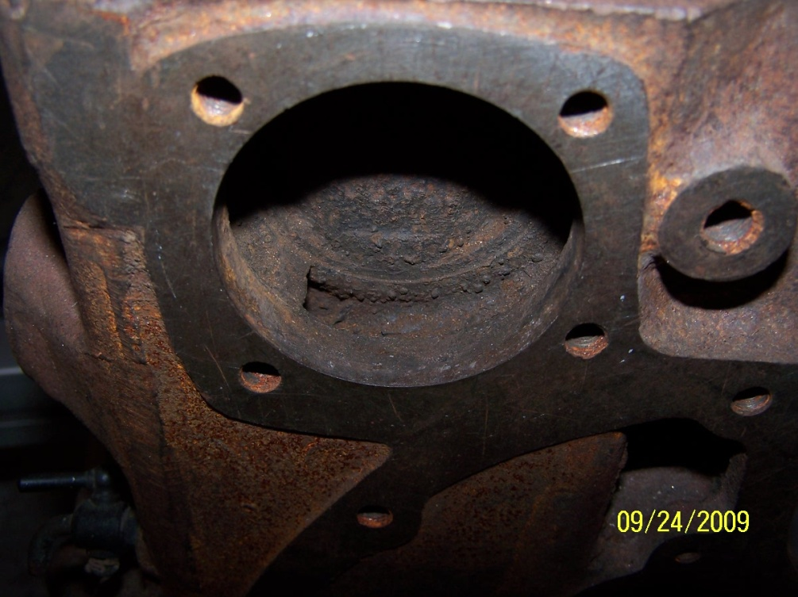
This next photo illustrates that the front passage is connected to the side passage.
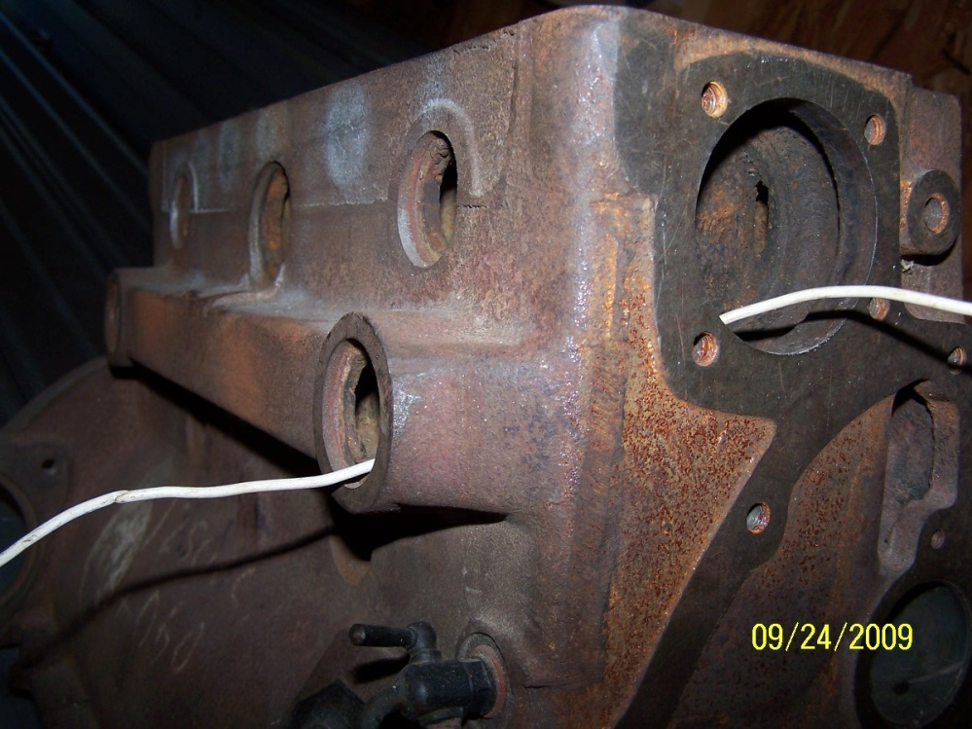

In this passage there should be two small holes leading into the block…one hole behind each core plug. The rear small hole will be on every block, the front one may or may not be. If the front hole is not there it’s easy to drill through the block to make it. I have read differing accounts as to their purpose (a release for the casting sand or simply to help the block fill with water) and to their need, but from personal experience I do know that by opening them up (mine were plugged) I dropped my operating temperature 10 degrees F. Other than these two small holes there are no other openings from this passage until it reaches the back of the block.
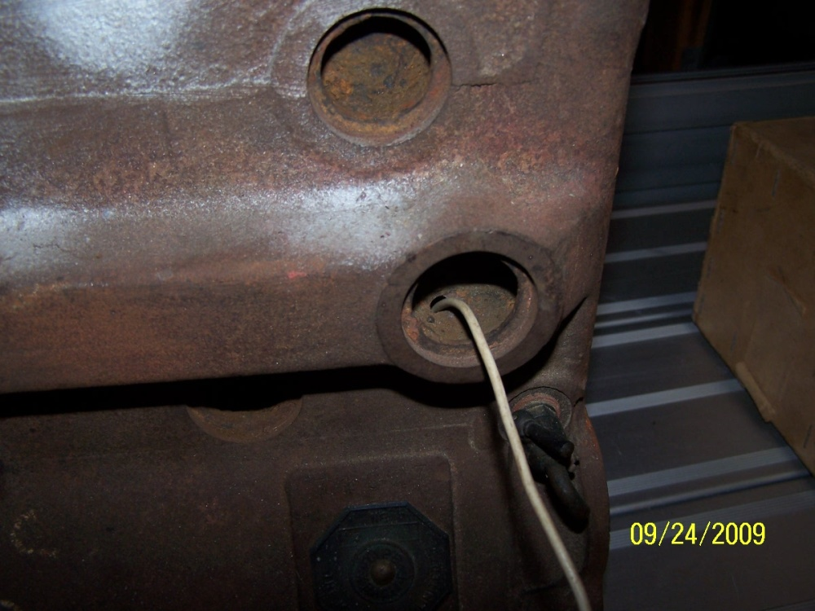
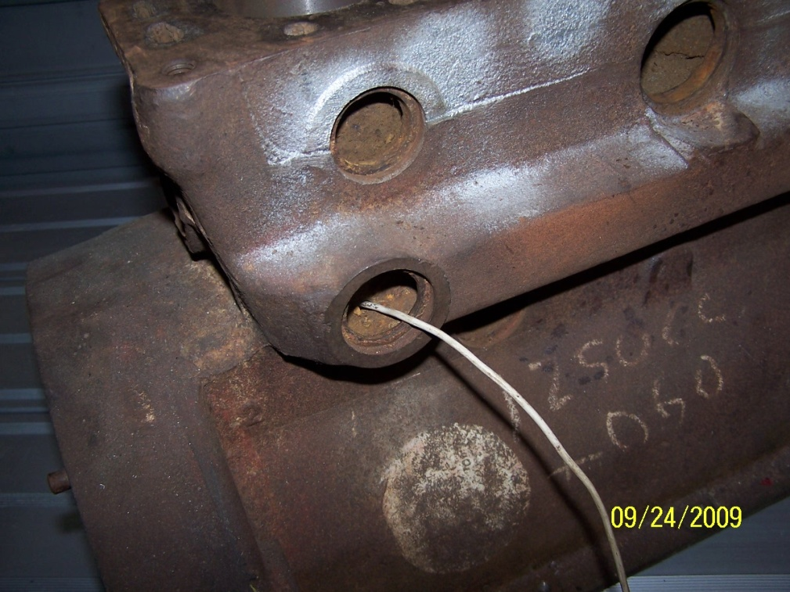

When the water reaches the rear of this passage it turns and goes up to the back of the head. There is no path into the block in this area except through the small hole behind the core plug. Remember that the water is relatively cool here so when it starts its journey through the head it will be extracting heat from this point forward. I could find no connection from this passage to the core plug opening on the back of the block.
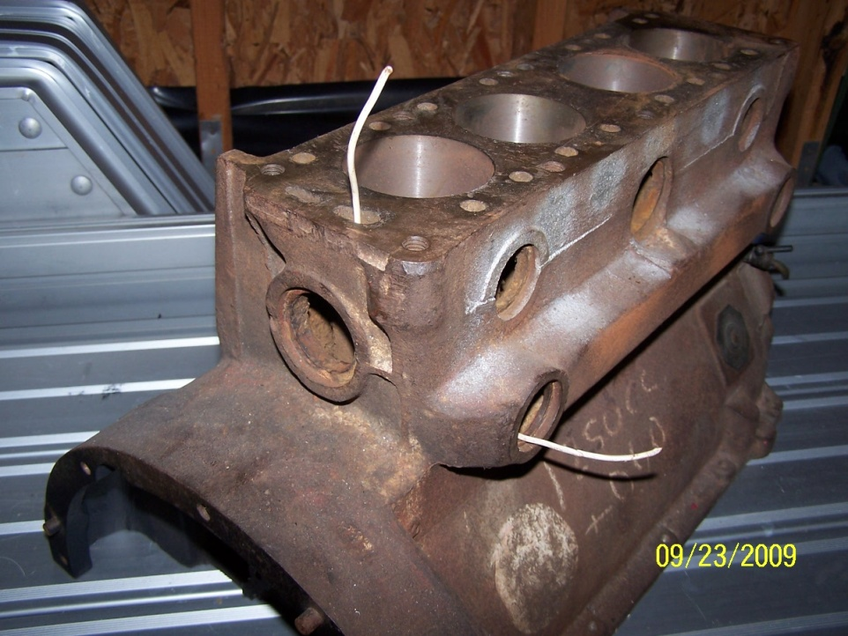
When the water exits the top of the block it goes into the head. As you can see the water comes in through the large opening at the rear of the head and into this chamber which connects to a passage that runs all the way through the head. NOTE: Although many people take their heater supply from the plate that covers this opening it’s obvious that the back of the head is cool…the heater supply should be taken from the front.
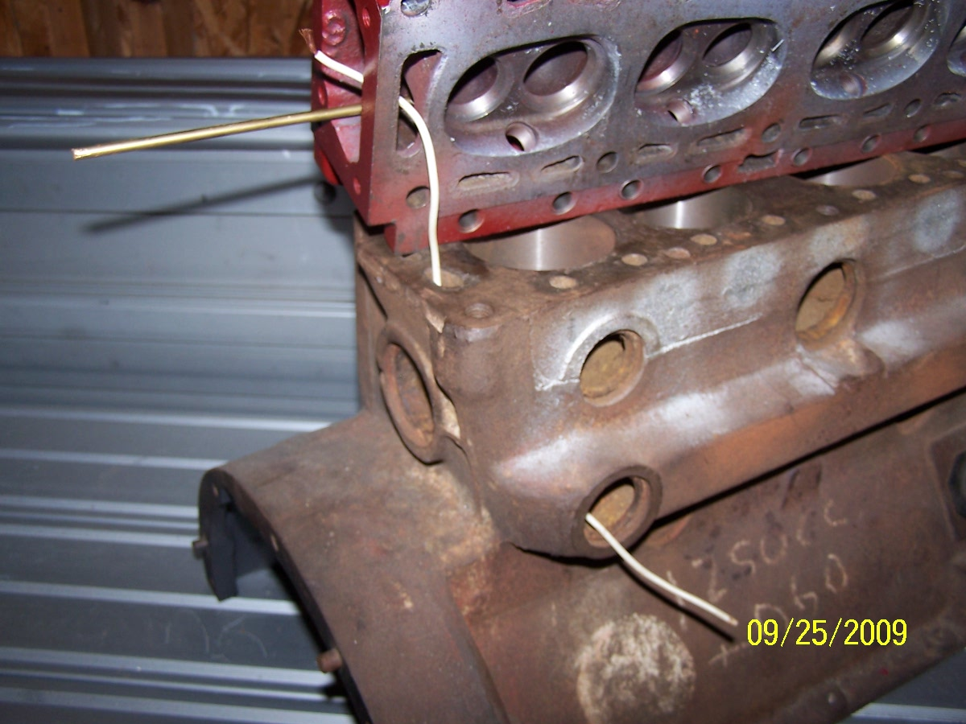

This passage is connected to the small openings (round or banana) that come up from the block…this is the thermo-siphon portion of the cooling system. The hot water/air rising from the internals of the block are mixed with the cooler water coming from the radiator and circulated around the head as it moves forward to the thermostat.
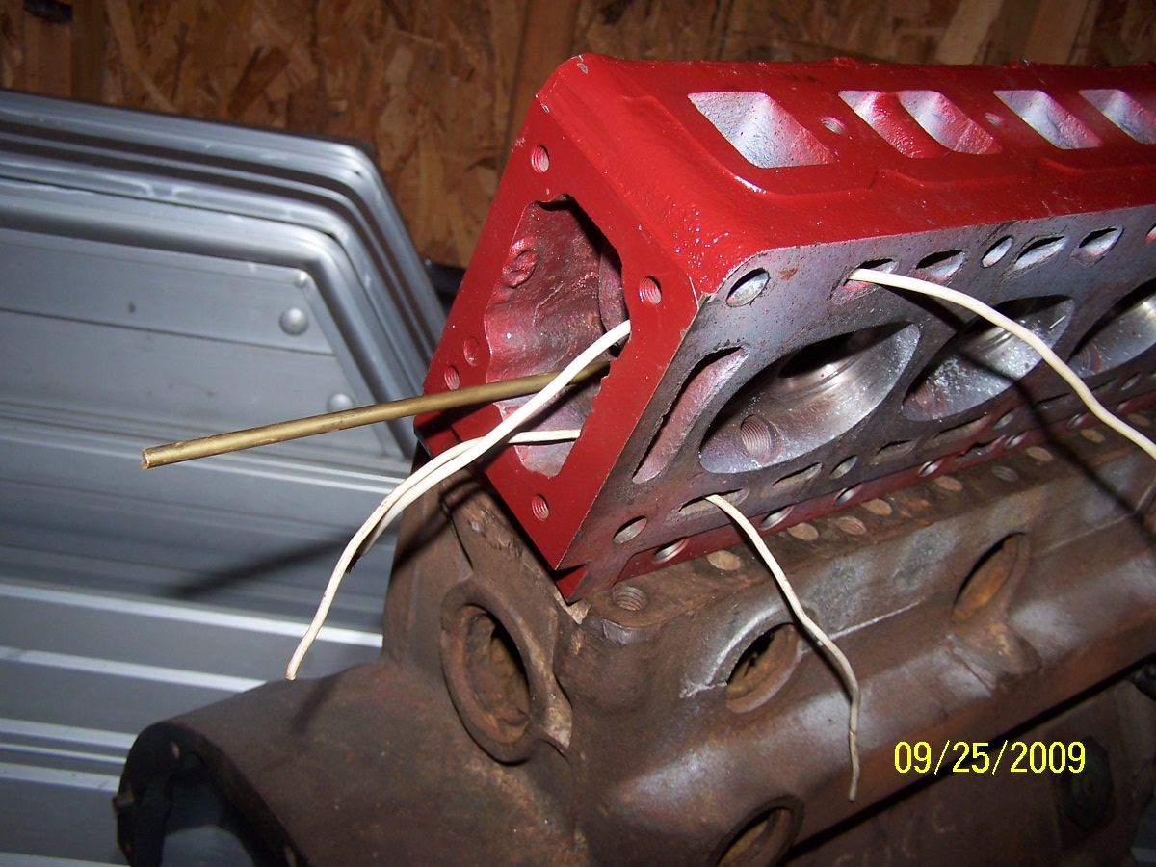

In this next photo I’ve inserted a brass rod all the way through the head to illustrate that there’s an unbroken water passage from front to rear. Again, as the heat and hot water rises from the block it’s picked up by the cooler water passing through the head on its way to the radiator.
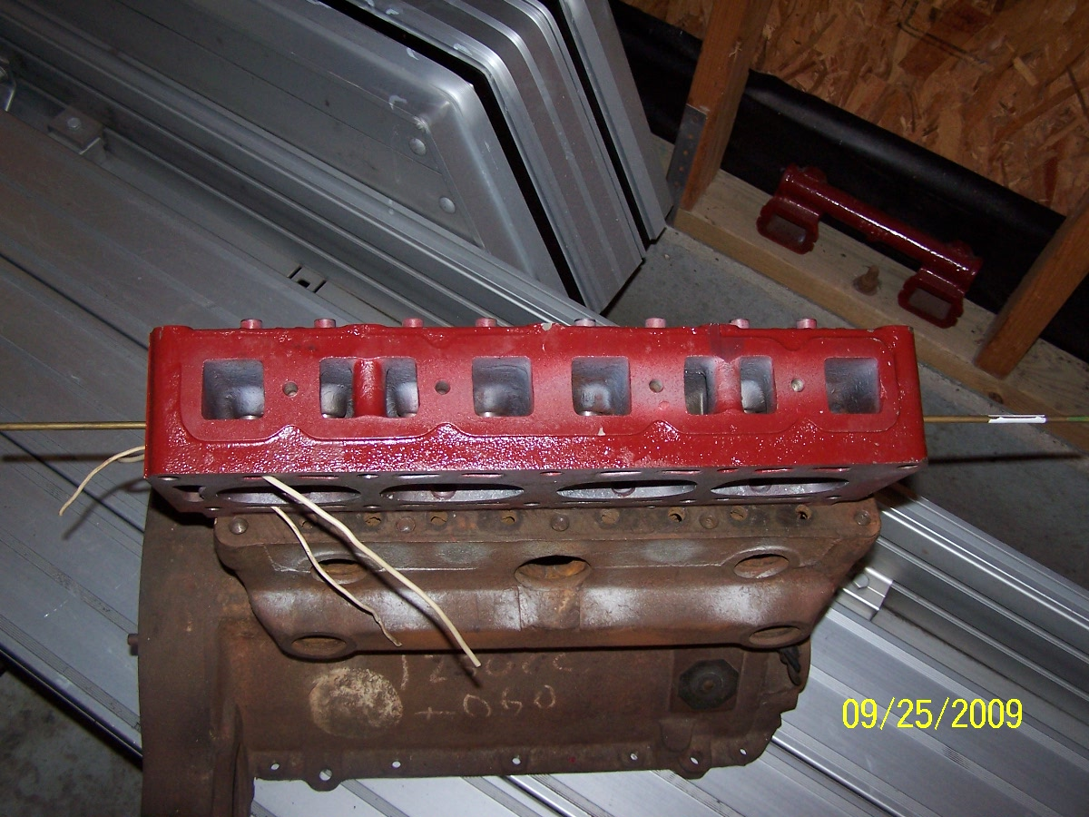

Now some photos to show how the rest of the cooling system is connected. With the exception of the square front to back passage the rest of the block is basically a water tank. As it heats the hotter water rises to the top of the block. This first photo shows how one of the small passages behind the water pump is connected to the front core plug and to the rest of the block.
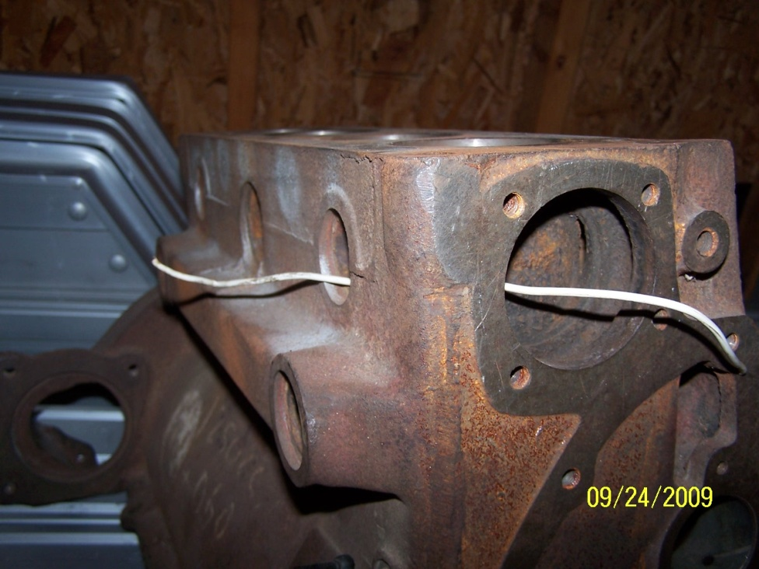
These next photos were taken to show that the block, with the exception of the piston cylinders is basically hollow and water is free to circulate (or stand) freely within it.
